|  |  |  |  |  |
| --- | --- | --- | --- | --- |
| Sl. No | Name of Certification Course | Name of Company / Certificate Provider | Total Course Hours | Certificate |
| 1 | Python for Machine Learning | GreatLearning | 5 Hours | ✅ |
| 2 | Introduction to Cyber Security | GreatLearning | 5.5 Hours | ✅ |
| 3 | Introduction to R | GreatLearning | 3 Hours | ✅ |
| 4 | Data Visualization Using Python | GreatLearning | 2 Hours | ✅ |
| 5 | Financial Risk Analytics | GreatLearning | 1.5 Hours | ✅ |
| 6 | RPA and its Applications | Alva's Institute of Engineering and Technology | - | ✅ |
| 7 | Step into Robotic Process Automation | GUVI | 1 Hour | ✅ |
| 8 | Data and Computer Communication Network | R. L Jalappa Institute of Technology | - | ✅ |
| 9 | Game Development using PyGame | GUVI | 1 Hour | ✅ |
| 10 | Technical Quiz | Netaji Institute of Engineering and Technology | - | ✅ |
| 11 | Introduction to Ethical Hackig | GreatLearning | 4 Hours | ✅ |
| 12 | Getting Started:Hadoop | GreatLearning | 5.5 Hours | ✅ |

Certificates:

1.

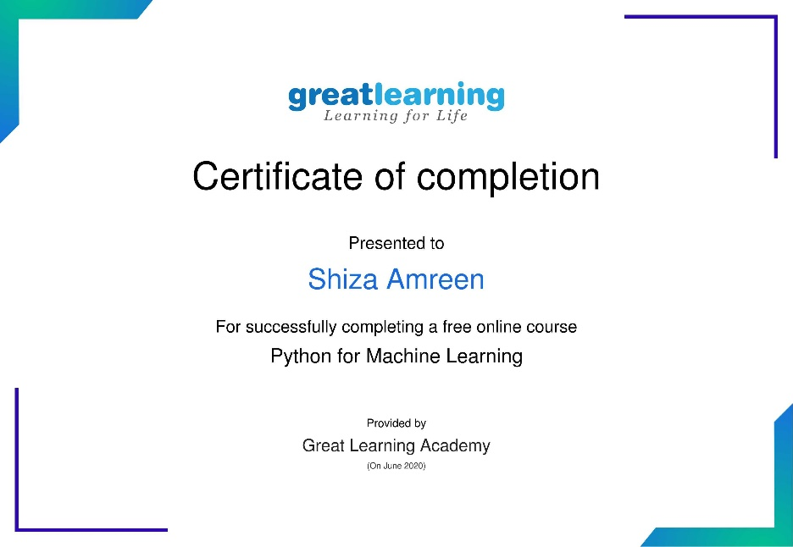

2.

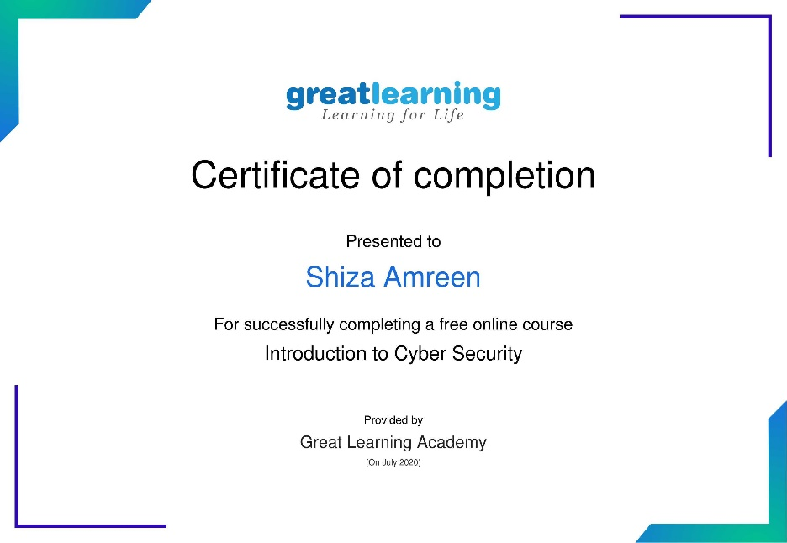

3.

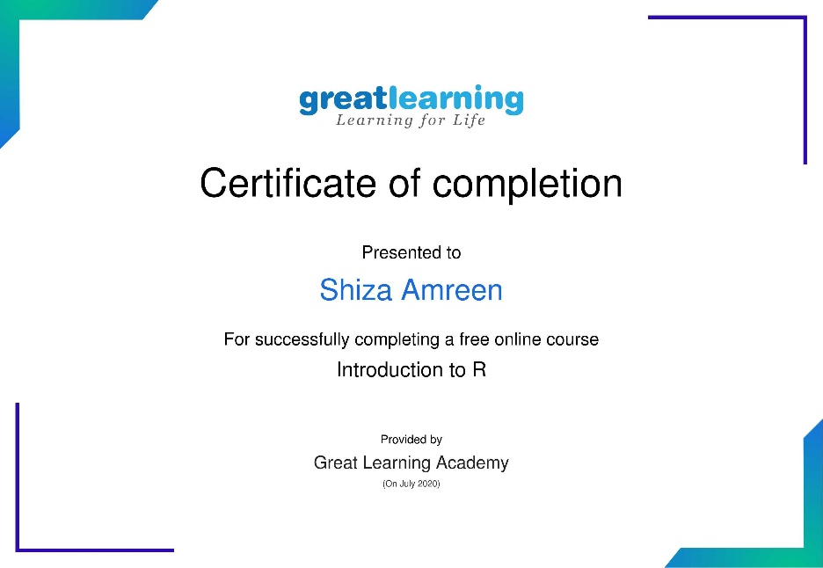

4.

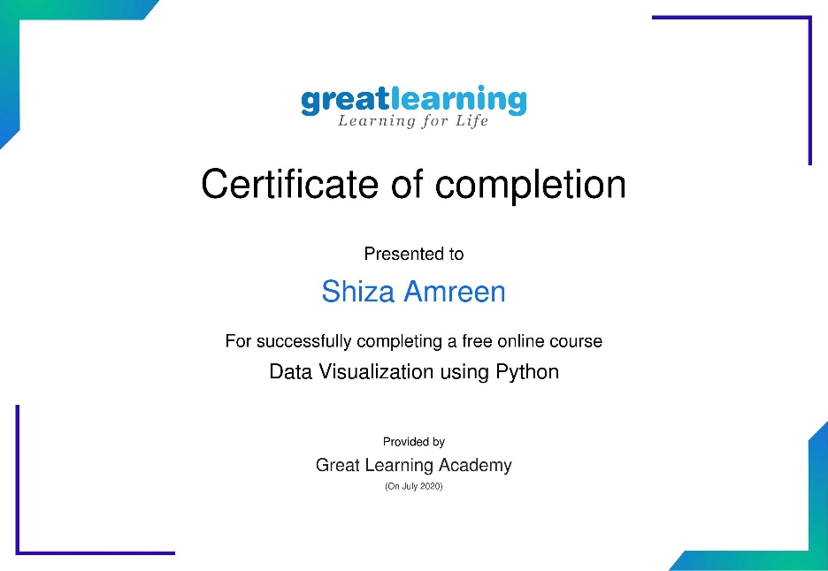

5.

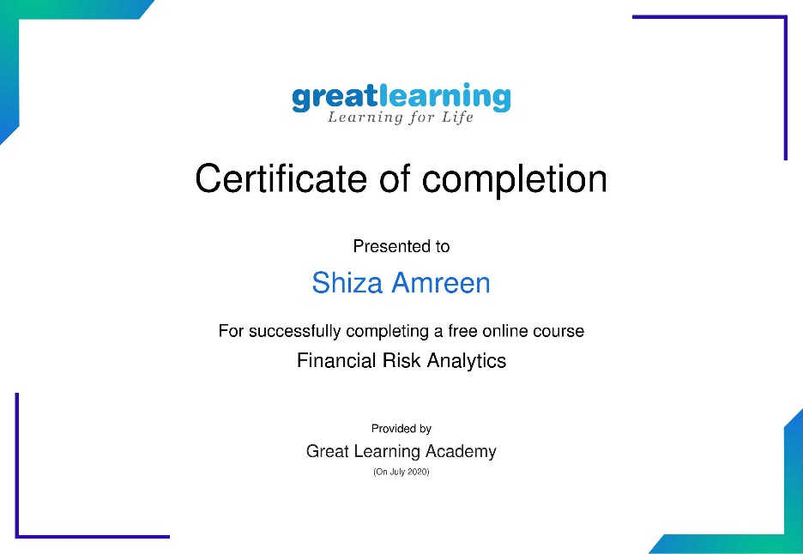

6.

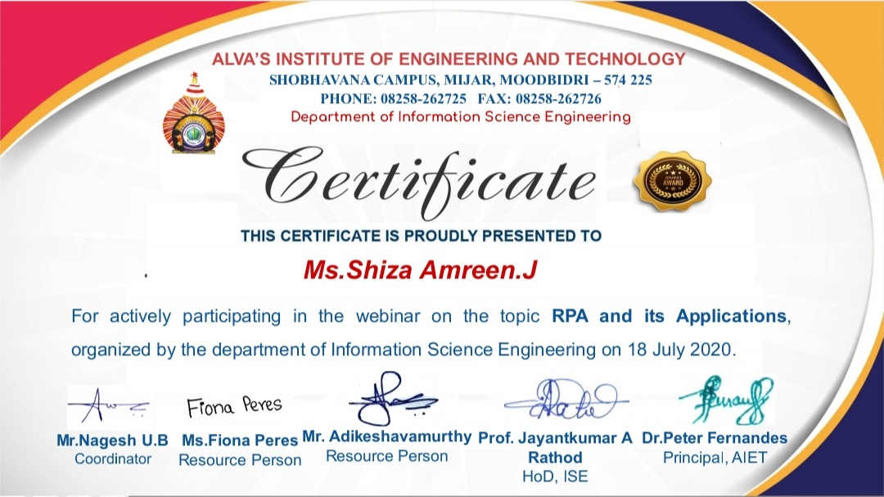

7.

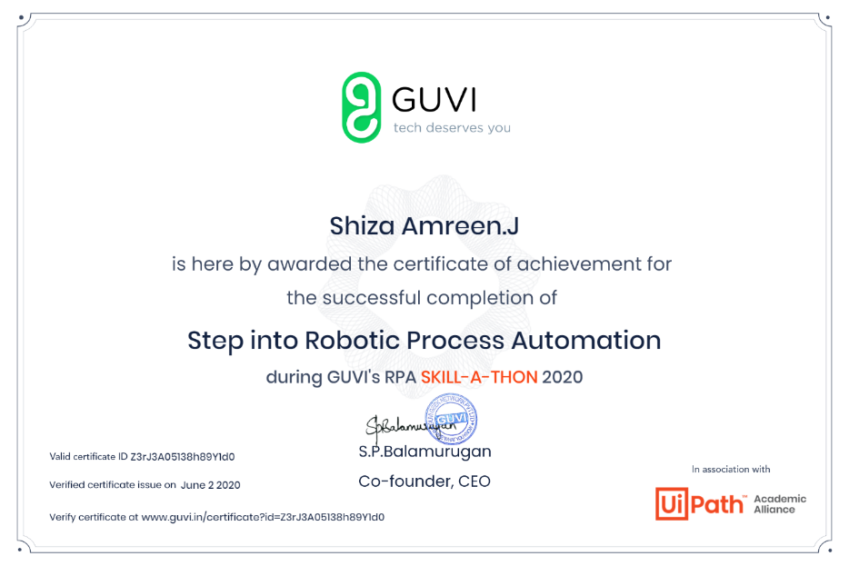

8.

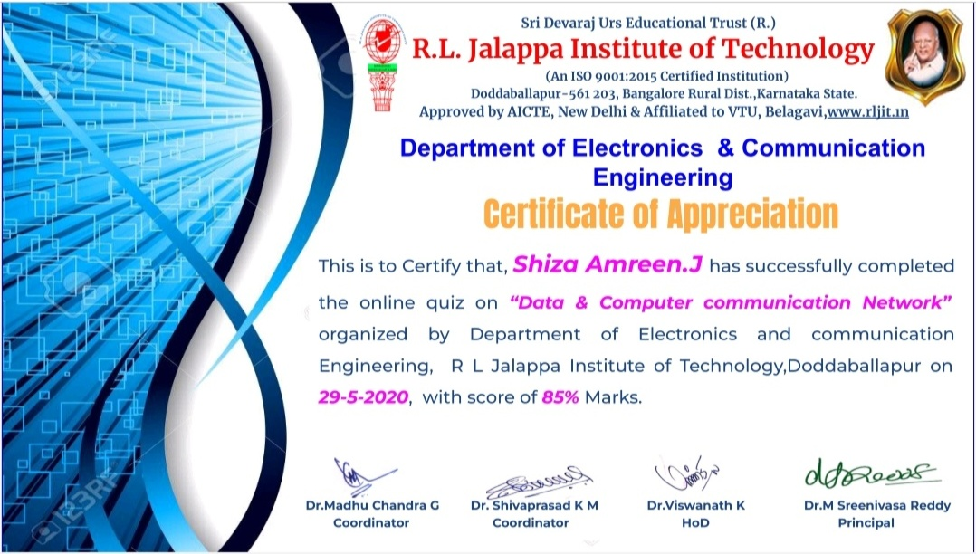

9.

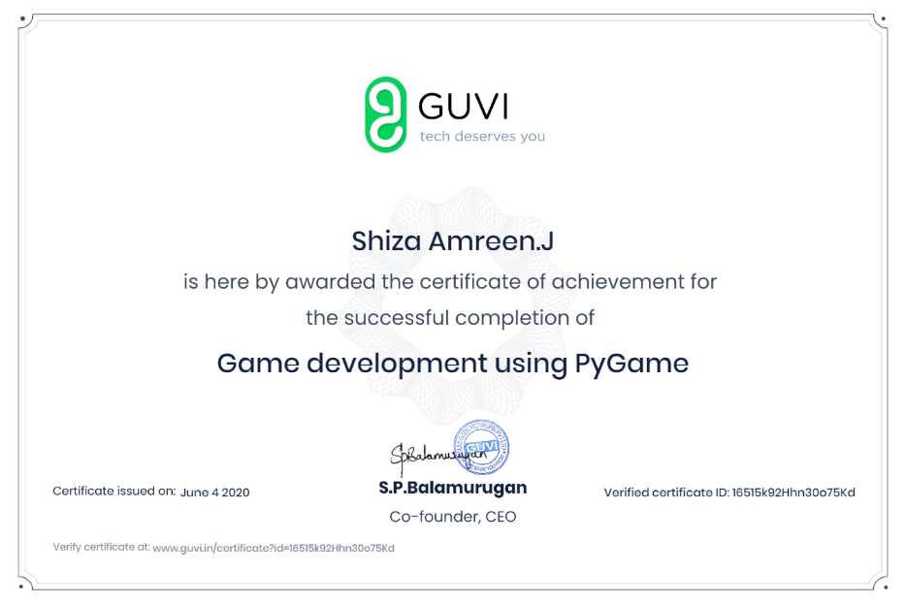

10.

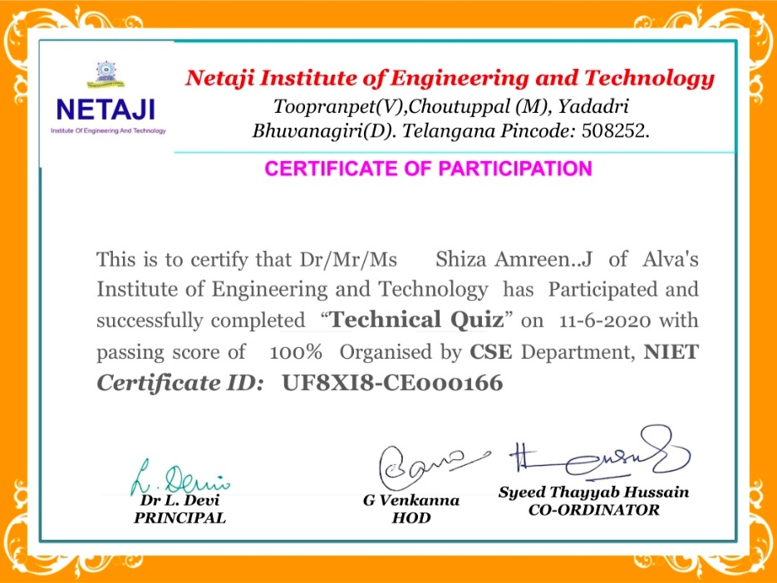

11.

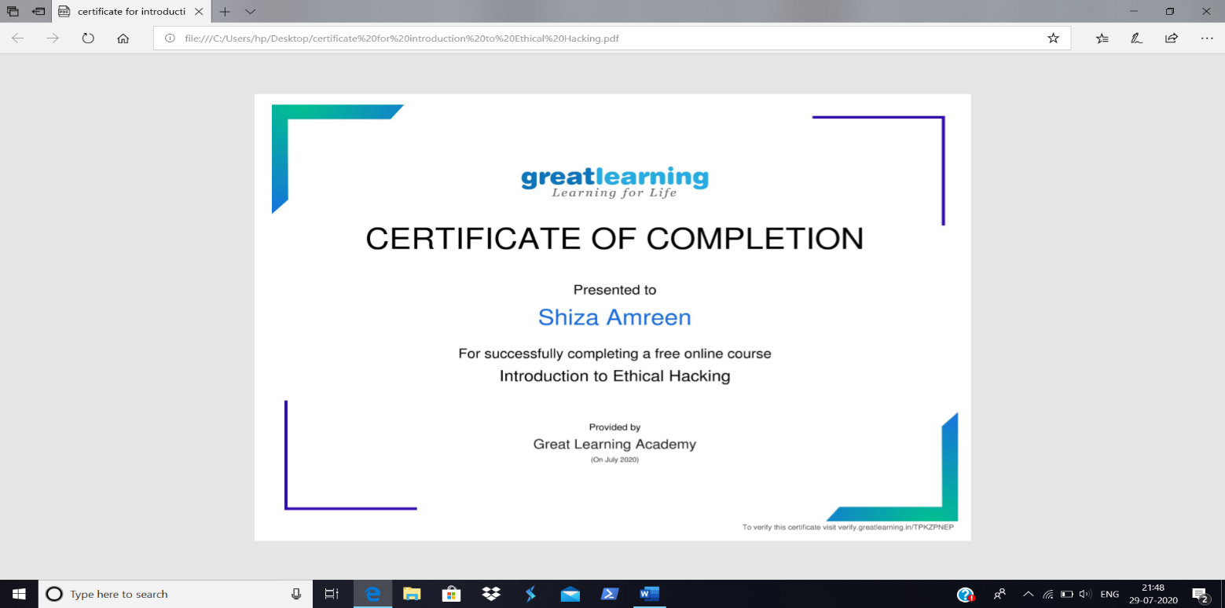

12.

